**Assignment – 3**

Problem Statement: Objects and arrays, Functions

1. Create an object.ts file which is declaring properties in key and value format and display result using object literal and perform for-in loop for same properties.
2. var person={
3. name:"Jhon", age:25, qualification:"Graduate", address:"xyz"
4. };
5. for(var obj in person){
6. console.log(person[obj]);
7. }
8. //html file
9. <html>
10. <title>TypeScript</title>
11. <script src="object.js"></script>
12. </html>

2. Create an array.ts file, declare the array in it and display the result of default index value.

var array:Array<any>=[1,2,3,"abc","def"];

console.log(array.indexOf("abc"));

//html

<html>

    <title>TypeScript</title>

    <script src="array.js"></script>

</html>

3. Write a function in typescript that will return ‘Hello’, perform parameter pass function for that code that should return ‘Hello Name’.(hello with sample name)

function append(str:string):string{

    return "Hello "+str;

}

console.log(append("Jhon"));

//html code

<html>

    <title>TypeScript</title>

    <script src="hello.js"></script>

</html>

4. Write a sample code to perform functional parameter as optional parameter, define default value of parameter, and perform function as parameter to another function.

function functions(id:number,name:string,role:string="None",age?:number){

    return id+" "+name+" "+role+" ";

}

function display(fun:any):void{

    console.log(fun(101,"Jhon"));

}

console.log(display(functions));

//html

<html>

    <title>TypeScript</title>

    <script src="1functions.js"></script>

</html>

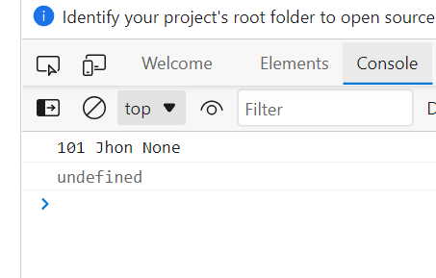

5. Create a sample hello function and make it as anonymous function, implement function overloading using ‘-doubleMe’ method.

var hello=function(){

    function doubleMe(x:any){

        if(x && typeof x==="number"){

            console.log("X type is number....");

        }else if(x && typeof x==="string"){

            console.log("X type is string....");

        }

    }

    doubleMe(7);

    doubleMe("Jhon");

}

hello();

//html

<html>

    <title>TypeScript</title>

    <script src="anonymous.js"></script>

</html>

